Assignment 1 : Draw your Home Network Topology and explain how you are accessing the RPS Lab environment.

Required internet connection from ISP.

Device required like mobile, laptop connected with router or ehternet.

visit on domain where RPS lab is hosted. After filling login credential we are good to go and ready to access RPS lab

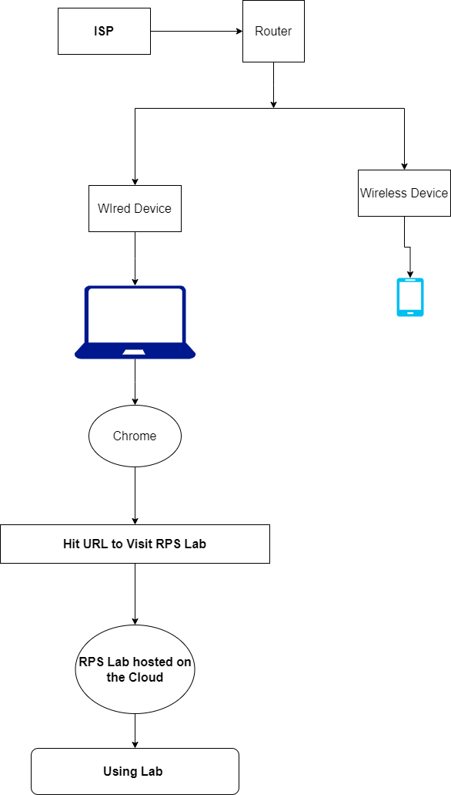

Assignmentt 2 : Identify a real-world application for both parallel computing and networked systems. Explain how these technologies are used and why they are important in that context.

**(a)There is many real word application for parallel computing few of them are :**

# **Supercomputers in Scientific works**  
Scientist used it as for wheater forecasting. Supercomputers equipped with parallel processing capabilities perform complex calculations in a fraction of the time. it aslo helpfull

# **Video post-production** involves tasks like 3D animation, color grading, and visual effects.  
Parallel computing breaks down tasks into smaller pieces and processes them simultaneously using multiple workers (threads or cores).

In video editing, parallel processing allows different effects or edits to happen concurrently. For example:  
While one thread applies color correction, another thread renders special effects.  
While one core stabilizes shaky footage, another core handles audio enhancements.

**#Large-scale databases and data warehouses.**Parallel computing accelerates data retrieval, indexing, and complex queries. It process queries across multiple nodes simultaneously, improving response times.

**(b) Real world Application for networked system**Computer networks, their importance lies in enabling seamless communication, collaboration, and critical applications across industries.  
 **# Computer Networking and Protocols:**Computer networks connect devices globally.Global networks allow users to connect with others worldwide. Whether it’s video conferencing, online transactions, or sharing knowledge, reliable connectivity is essential.

**# Internet of Things (IoT):**It connect the device over internet. Collecting data from sensors, controlling smart devices, and enabling automation.